University of Wisconsin/Toronto Blue Jays Upper Extremity Athlete Physical Therapy fellowship 2023-2024

This is a 14-month physical therapy fellowship program in collaboration with MLB’s Toronto Blue Jays to develop physical therapists’ skill set to effectively manage the care of athletes in upper extremity sports.

Program:
- Six months of training at UW Health Sports Rehabilitation in Madison WI (September-February)
  - 32 hours of direct patient care at UW Health Sports Rehabilitation Clinic
    - 2-3 mentored hours a week with direct patient care and with biomechanical throwing analysis
  - 4 hours a week working with Upper Extremity fellowship trained Orthopedic surgery clinic
  - 2-6 hours a week didactic coursework, learning/teaching, research/project development
  - 2-4 hours a week of sports performance training
  - Clinical Teaching within the sports residency program
  - Surgical observation
- Six months Of Training in Dunedin Florida with the Toronto Blue Jays organization (March-August)
  - Athletic training room care and field coverage of Spring Training and Regular Season Games with Certified Athletic Trainers and Physical Therapists
  - Injury Prevention of Healthy Major and Minor League Baseball Players
  - Injury Rehabilitation of Major and Minor League Baseball Players
  - Learning Opportunities with other High Performance Departments (Mental Skills, Sports Science, Strength/Conditioning, Nutrition)
  - Opportunities for Observation/Learning with Major League Baseball Team Physicians

- Two Months of training at UW Health Sports Rehabilitation in Madison WI (September-October)
  - 32 hours patient care
  - Develop and delivery of didactic course work/projects

Requirements
- Current CV
- 3 letters of recommendation
- WI/Florida License prior to start of the fellowship
- ABPTS specialist certification or completion of an ABPTRFE-accredited residency in Sports

Preferred
  - Licensed Athletic trainer, Certified emergency responder or Licensed EMT

Apply: https://eimy.fa.us6.oraclecloud.com/hcmUI/CandidateExperience/en/sites/CX_1/requisitions?keyword=28173

Contact information:

Marc Sherry
408-440-6291
msherry@uwhealth.org
Dan Enz
608-265-8312
denz@uwhealth.org
Adam Ingle
Adam.ingle@bluejays.com
Andrew Pipkin
Andrew.Pipkin@bluejays.com

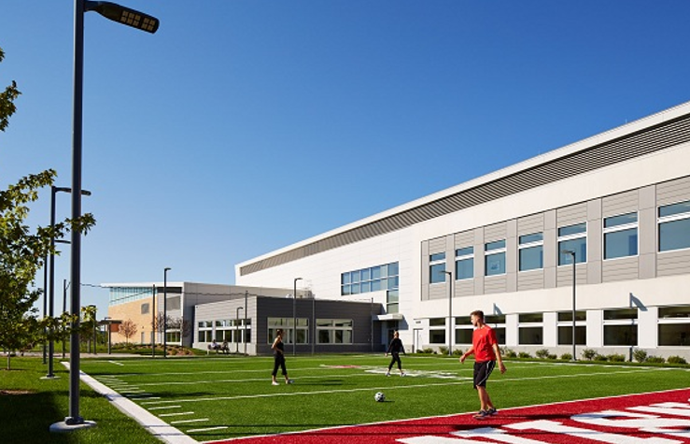
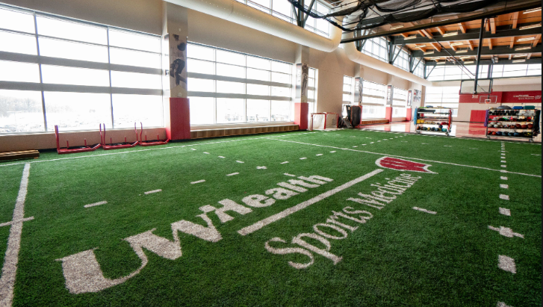
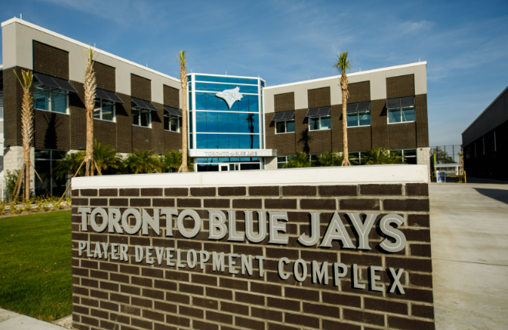
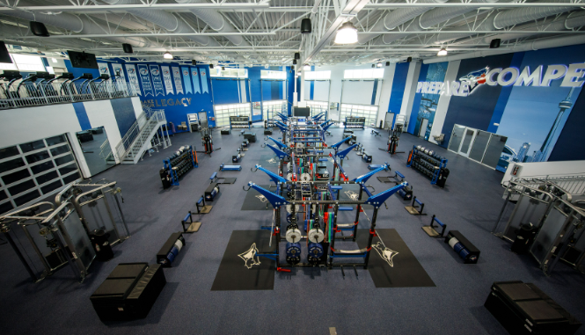
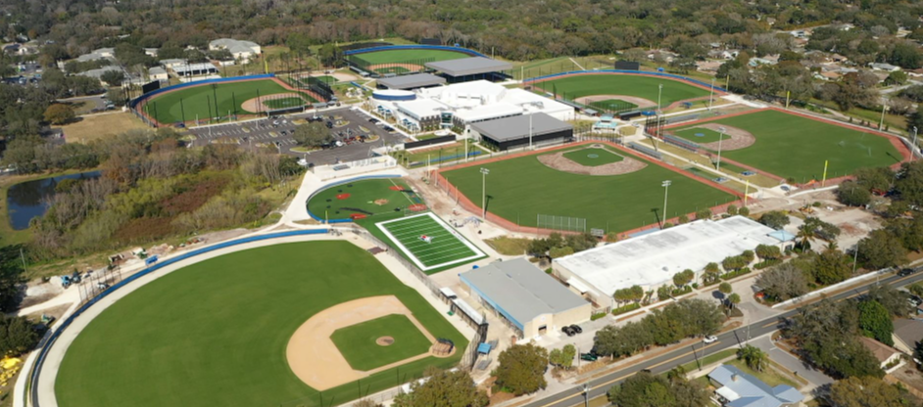

Expedite your professional growth through didactic work, one-on-one clinical mentoring, research activities, outreach experiences, multi-disciplinary educational lectures, sports performance experiences, and case presentations. Develop a sub-specialty within the upper extremity and professional athletics by working with youth, high school, college and professional athletes at UW Sports Rehabilitation for 8 months, and working directly with the players and rehab professionals of the Toronto Blue Jays for 6 months.
Join the #1 hospital in Wisconsin and a Major League Baseball organization!

We are seeking a an Upper Extremity Sports Physical Therapy Fellow to:
- Attend and participate in didactic education designed to advance clinical reasoning and pattern recognition in sports medicine and sports physical therapy.
- Challenge their own clinical decision making through constructive feedback in didactic units and case presentations.
- Form alliances with patients and their families with the common goal of optimizing function and return to sport following acute injuries, surgical procedures and non-traumatic impairments.
- Learn advanced level clinical biomechanics for evaluation and treatment in our upper extremity specialty clinics –swimmers, throwers, strength and power and sports performance.
- Receive and modify practice patterns based on constructive feedback from mentors.
- Participate in education by teaching in the sports medicine education series, the sports medicine symposium, and various outreach programs.
- Collaborate on a weekly basis with board certified and fellowship trained sports medicine physicians and surgeons.
- Treat a variety of post-operative sports medicine conditions while being mentored by staff.
- Work in our state-of-the-art facilities
  - UW Health: 28,000 square foot sports rehab facility at East Madison Hospital that has an indoor turf field, 2 pools, a full-size basketball court, a golf hitting area with a K-vest, a sprint track and functionally based weight room with Keiser power racks. There is also an outdoor turf field, a mondo surface training space, a training sand pit, and a training hill.
  - Toronto Blue Jays Player Development Complex: Sitting on a 65-acre site, the new Player Development Complex (PDC) is the training facility of the Toronto Blue Jays Major and Minor League operations. The 115,000 square-foot building is located at 3031 Garrison Road, Dunedin, approximately 10 minutes away from TD Ballpark where the Blue Jays play their games.

Player Development Complex Features:
· 6 Fields (5 brand new) | · Sports Science Labs
· 2 Half Fields | · Hydrotherapy Room (hot/cold tubs, pool)
· Covered Practice Field | · Training Room
· 20 Gang Mounds | · Clubhouse (lockers, equipment & laundry rooms)
· 12 Covered Batting Cages | · Kitchen & Dining Areas
· Speed Hill | · Workrooms, Conference & Meeting Rooms
· Observation Tower | · Media Room
· Weight Room | · Barber Shop & Nutrition Stations
· Movement Studio | · Player Lounge & Family Room

